USACE ADVANCED MODELING
PROJECT EXECUTION PLAN
(PxP) – V4.0

TRANSMITTAL NO: [TRANSMITTAL NUMBER]

FOR
[FACILITY OWNER]

[PROJECT TITLE]
[PROJECT LOCATION]
USACE CONTRACT NUMBER: [CONTRACT NUMBER]
[TASK ORDER NUMBER – as applicable]
[PROJECT NUMBER (PN) – as applicable]
[OTHER AGENCY PROJECT CODE(S) – as applicable]

[SUBMITTAL DATE]

DEVELOPED BY
[PROJECT CONTRACTOR]



INSTRUCTIONS AND REFERENCE INFORMATION
This template is a tool that is provided to assist in the development of an Advanced Modeling Project Execution Plan (PxP) as required per Awarded Contract or Proposal Submission Requirements, or for use on a USACE District In-house design project. It was adapted from the United States National BIM Standard (NBIMS–USTM). For Reference Information needed to complete content in this template, such as Model Use definitions, see the NBIMS–USTM Chapter 5 Practice Documents and related Section 5.3 BIM Project Execution Planning Guide at www.nationalbimstandard.org.
The U.S. Army Corps of Engineers is an Alliance Sponsor Member of the National Institute of Building Sciences (NIBS) http://www.nibs.org. NBIMS–USTM is a product of the buildingSMARTalliance® (bSa) which serves as a Council of NIBS http://www.nibs.org/?page=bsa.
Bracketed GRAY TEXT is to be modified as needed to document the project. If modified, the format of the text should be changed to match the rest of the document. This can be completed, in most cases, by selecting the Normal Style in the template styles. Contractor shall not delete any sections or paragraphs. If a section or paragraph is not applicable to the project, mark it as such.
The terms ‘Organization’ and ‘Submitter’ can refer to a USACE in-house design team, other government entity, contractor or company.
If the PxP is being developed by USACE personnel for an in-house design project, instructions or references to a Contractor are applicable to the USACE Project Delivery Team.
Questions pertaining to an individual solicitation shall be directed to the advertising District's Contracting Specialist for that Solicitation.

TABLE OF CONTENTS
SECTION 1: PROJECT INFORMATION 1
SECTION 2: KEY PROJECT CONTACTS 3
SECTION 3: PROJECT MODEL USES 5
SECTION 4: ORGANIZATIONAL ROLES / STAFFING 7
SECTION 5: ADVANCED MODELING PROCESS DESIGN 8
SECTION 6: MINIMUM MODELING AND DATA REQUIREMENTS 9
SECTION 7: COLLABORATION PROCEDURES 10
SECTION 8: QUALITY CONTROL 11
SECTION 9: TECHNOLOGICAL INFRASTRUCTURE NEEDS 13
SECTION 10: ADVANCED MODELING ORGANIZATION 15
SECTION 11: PROJECT DELIVERABLES 16
SECTION 12: GEOGRAPHIC INFORMATION SYSTEM (GIS) 17
SECTION 13: GOVERNMENT FURNISHED MATERIAL (GFM) 17
SECTION 14: ATTACHMENTS 17
SECTION 15: TEMPLATE CHANGE LOG 17

SECTION 1: PROJECT INFORMATION
To successfully execute Advanced Modeling requirements on a project, [CONTRACTOR] has developed this detailed Advanced Modeling PxP. The PxP defines Project Model Uses on the project, along with detailed processes for executing Advanced Modeling requirements and options on this project.
[INSERT OPTIONAL INFORMATION; FOR EXAMPLE, AN ADVANCED MODELING MISSION STATEMENT. This is the location to provide up to one paragraph of additional Advanced Modeling overview information. Additional detailed information can be included as an attachment to this document.]
- PROJECT INFORMATION
PROJECT INFORMATION | NUMBER / DESCRIPTION
FACILITY OWNER | [e.g., US ARMY, USACE OR OTHER AGENCY]
PROJECT TITLE | [e.g., BATTALION HEADQUARTERS, FISH PASSAGE FACILITY]
PROJECT LOCATION | [e.g., JOINT BASE LEWIS-MCCHORD, WA; WOLF CREEK DAM, KY]
USACE CONTRACT NUMBER | [e.g., W9126G-08-D-0000]
CONTRACT TASK ORDER | [AS APPLICABLE, e.g., 0001]
PROJECT NUMBER (PN) | [AS APPLICABLE, e.g., PN055198]
OTHER AGENCY PROJECT CODE(S) | [IF APPLICABLE, AS ASSIGNED BY OTHER AGENCY]
CONTRACT DELIVERY METHOD | [e.g., DESIGN-BUILD, DESIGN-BID-BUILD, CONSTRUCTION, ETC.]
CONTRACTOR INFORMATION | NUMBER
PROJECT CONTRACTOR | [NAME OF AE DESIGN OR CONTRACTOR FIRM]
CONTRACTOR PROJECT NUMBER(S) | [AS ASSIGNED BY CONTRACTOR]
CONTRACTOR PROJECT CODE(S) | [AS ASSIGNED BY CONTRACTOR]

- BRIEF PROJECT DESCRIPTION
[General scope, size, and description of the infrastructure or facility. If more than one facility, describe number and type of structures, e.g. a ‘Battalion Complex’ may consist of a Battalion Headquarters facility and a Dining Facility.]

- ADDITIONAL PROJECT INFORMATION
[Unique Advanced Modeling project characteristics and requirements]

- ADVANCED MODELING GOALS
This section is a planning tool for the Project Team (Team) to utilize while determining the goals for the project. The goals identified through this process assist in determining which Model Uses will need to be accomplished to reach the goals. Since this is a planning tool, no items in this section are to be considered required by the Contract, and are For Information Only.

The Team should complete this section at the earliest possible stage of developing the PxP. The Team should meet and discuss the project objectives, unique characteristics, technology scenarios, etc. to determine what the goals of the project should be.

The potential goals should be listed in the Goal Description column as the brainstorming session occurs. Example goal descriptions are: Use Geometry for Structural Analysis Models, Assess Project Costs, Optimize Construction Schedule, etc.

Next, identify each Project Model Use from Section 3.3 that will need to be executed to achieve each goal. For example, the ‘Use Geometry for Structural Analysis Models’ goal would be implemented via the ‘Structural Analysis’ Model Use and definition.

Once the potential goals are identified, each should be given a Priority of importance to the project (High, Medium or Low). This will narrow down the goal list to only what the Team believes should be executed on the project.

If goals are identified by the Team which are to be executed, but are not required by USACE, discussions should take place between USACE and the Team at this point. Some goals will require additional funding and time to achieve but may be justifiable based upon their value.

ADVANCED MODELING GOALS
PRIORITY | GOAL DESCRIPTION | PROJECT MODEL USES
[HIGH] | [3D Model surveys of existing site surface and subsurface utilities are used in Pre-Design and Design stages to reduce risk of site design errors and omissions] | [EXISTING CONDITIONS MODELING]
[HIGH] | [Optimize Construction Schedule] | [CONSTRUCTION SCHEDULING (4D)]
[HIGH] | [Assess Project Costs] | [COST ESTIMATION (5D)]
[MEDIUM] | [Use Geometry for Structural Analysis Models] | [STRUCTURAL ANALYSIS]

- PROJECT PxP CHANGE LOG
If any items in an approved PxP are required by an organization to be changed during the course of the project, consult with the District BIM/CIM Manager or Delegate to determine if a resubmittal of the PxP is required. If a resubmittal is required, all changes to the approved PxP are to be logged below providing a date, section number and brief description of each change.

PROJECT PxP CHANGE LOG
DATE | SECTION | DESCRIPTION

SECTION 2: KEY PROJECT CONTACTS
The following are lists of the Key Project Contacts for modeling activities of each organization on the project. As needed, additional contacts can be included later. The roles currently shaded in red are required by USACE.

- USACE / AGENT CONTACTS
USACE/AGENT ROLE | ORGANIZATION | NAME | EMAIL |  | TIME ZONE | PHONE
PROJECT MANAGER | [USACE]
[PROJECT MANAGER] | [Government, other than USACE]
DISTRICT BIM/CIM MANAGER | [USACE / AGENT]

- CONTRACTOR CONTACTS FOR ADVANCED MODELING ACTIVITIES
Discipline Advanced Modeling Leads are assigned for each discipline identified in the Section 6.1, ‘M3: Attachment 3, Tab 3’ as being included in the project (Elements in the M3 Tab ‘03. Scope-LOD-Grade’ are marked ‘Yes’), and others as required.
CONTRACTOR ROLE | ORGANIZATION | NAME | EMAIL | TIME ZONE | PHONE
PROJECT MANAGER(S) | [Company/NA]
BIM/CIM MANAGER(S) | [Company/NA]
[ARCHITECTURE LEAD] | [Company/NA]
[CIVIL LEAD] | [Company/NA]
[ELECTRICAL/TELECOM LEAD] | [Company/NA]
[EQUIPMENT LEAD] | [Company/NA]
[FIRE PROTECTION LEAD] | [Company/NA]
[GEOTECHNICAL LEAD] | [Company/NA]
[GIS LEAD] | [Company/NA]
[HAZARDOUS MATERIALS LEAD] | [Company/NA]
[INTERIORS LEAD] | [Company/NA]
[MECHANICAL (HVAC) LEAD] | [Company/NA]
[PLUMBING LEAD] | [Company/NA]
[SPECIALITY CONSULTANTS] | [Company/NA]
[STRUCTURAL LEAD] | [Company/NA]
[SURVEY/MAPPING LEAD] | [Company/NA]
[OTHER] | [Company/NA]

SECTION 3: PROJECT MODEL USES
- MANDATORY MODEL USES
The Model Uses in Section 3.3 shaded in red and identified with an (X) must remain as MANDATORY Model Uses on the project. Reference the BIM Project Execution Planning Guide at www.nationalbimstandard.org for descriptions of Model Uses.

- ELECTIVE MODEL USES (NON-CONTRACTUAL / INNOVATIVE MODEL USES) - OPTIONAL
As supplementary to the Mandatory Model Uses in Section 3.3, Contractor may choose to implement Elective Model Uses (Non-Contractual / Innovative Model Uses) either through identifying non-mandatory Model Uses as electives or adding Contractor-developed innovative Model Uses. This option provides the Contractor with two benefits; a method to attempt non-mandatory Model Uses without fear of negative consequences if the execution does not go as planned, and also a method to demonstrate to USACE Model Uses that have been executed well. All submitted Elective Model Use content is considered non-contractual in nature and will not be negatively evaluated or critiqued by USACE, but MUST be properly documented in Sections 3.2.a, b and c.
  - Provide in the table below a ‘Process Description and Added-Value’ for each Elective Model Use chosen or developed for the project.

  - All Elective Model Uses are to be identified with an (E) in Section 3.3 in the Design or Construct columns only. Do not identify or add Elective Model Uses in the Plan or Operate columns.

  - Provide information in Section 11.2 concerning any related submittals. Submittals may be submitted as ‘For Information Only’.

ELECTIVE MODEL USE | PROCESS DESCRIPTION and ADDED-VALUE
[ELECTIVE MODEL USE] | [DESCRIPTION]

- PROJECT MODEL USES
Project Model Uses are the combination of ‘Mandatory Model Uses’ in Section 3.1 and the ‘Elective Model Uses’ in Section 3.2, and identified in the table below.

PROJECT MODEL USES
PLAN  (NOT IN CONTRACT) |  | DESIGN |  | CONSTRUCT | OPERATE  (NOT IN CONTRACT)
PROGRAMMING | X | DESIGN AUTHORING |  | SITE UTILIZATION PLANNING | BUILDING SYSTEM ANALYSIS
SITE ANALYSIS | X | PROGRESS REVIEWS |  | CONSTRUCTION SYSTEM DESIGN | ASSET MANAGEMENT
 | X | INTERFERENCE MANAGEMENT  (3D COORDINATION) | X | INTERFERENCE MANAGEMENT  (3D COORDINATION) | SPACE MANAGEMENT / TRACKING
 |  | STRUCTURAL ANALYSIS |  | DIGITAL FABRICATION | DISASTER PLANNING
 |  | LIGHTING ANALYSIS |  | 3D CONTROL AND PLANNING (DIGITAL LAYOUT)
 |  | ENERGY ANALYSIS | X | RECORD MODELING | OPERATION & MAINTENANCE  RECORD MODELING
 |  | PROGRAM VALIDATION |  | FIELD / MATERIAL TRACKING
 |  | MECHANICAL ANALYSIS |  | PROGRAM VERIFICATION
 |  | OTHER ENG. ANALYSIS
 |  | SUSTAINABILITY (LEED) EVALUATION
 |  | CODE VALIDATION
PHASE PLANNING (4D) |  | PRELIMINARY CONSTRUCTION SCHEDULING (4D) |  | CONSTRUCTION SCHEDULING (4D) | BUILDING MAINTENANCE SCHEDULING (4D)
COST ESTIMATION (5D) |  | COST ESTIMATION (5D) |  | COST ESTIMATION (5D) | COST ESTIMATION (5D)
EXISTING CONDITIONS MODELING |  | EXISTING CONDITIONS MODELING |  | EXISTING CONDITIONS MODELING | EXISTING CONDITIONS MODELING
FACILITY DATA EXCHANGE (FDE) |  | FACILITY DATA EXCHANGE (FDE) |  | FACILITY DATA EXCHANGE (FDE) | FACILITY DATA EXCHANGE (FDE)

LEGENDEL U
X | MANDATORY MODEL USE
E | ELECTIVE MODEL USE

- INTEGRATION OF PROJECT MODEL USES IN OTHER SECTIONS
All Project Model Uses identified in Section 3.3 are to be integrated into the following Sections as well. All Elective Model Use content provided is considered non-contractual in nature and will not be negatively evaluated or critiqued by USACE, but MUST be properly documented in Sections 3.2.a, b and c.

4.1 | DESIGN PHASE PROJECT MODEL USE | 8.2 | QUALITY CONTROL CHECKS
4.2 | CONSTRUCTION PHASE PROJECT MODEL USE | 9.1 | DESIGN PHASE SOFTWARE
5.1 | LEVEL ONE - PROCESS OVERVIEW MAP: ATTACHMENT 1 | 9.2 | CONSTRUCTION PHASE SOFTWARE
5.2 | LEVEL TWO - DETAILED PROCESS MAPS: ATTACHMENT 2 | 11.2 | PROJECT DELIVERABLES FOR ELECTIVE MODEL USES

SECTION 4: ORGANIZATIONAL ROLES / STAFFING
For each Project Model Use identified in Section 3.3, noting each applicable Contractor on the Team, identify the organization (or organizations) responsible for staffing and implementation. Staff members may fill multiple project roles.

- DESIGN PHASE PROJECT MODEL USES
DESIGN PHASE  MODEL USE | ORGANIZATION | OFFICE LOCATION(S) | LEAD CONTACT
DESIGN AUTHORING | [Contractor A]
PROGRESS REVIEWS | [B]
INTERFERENCE MANAGEMENT  (3D COORDINATION) | [C]
[ELECTIVE MODEL USE] | [D]

- CONSTRUCTION PHASE PROJECT MODEL USES
CONSTRUCTION PHASE  MODEL USE | ORGANIZATION | OFFICE LOCATION(S) | LEAD CONTACT
INTERFERENCE MANAGEMENT  (3D COORDINATION) | [E]
RECORD MODELING | [F]
[ELECTIVE MODEL USE] | [G]

SECTION 5: ADVANCED MODELING PROCESS DESIGN
Provide a Process Overview Map and Detailed Process Maps that demonstrate how all Project Model Uses identified in Section 3.3 will be implemented. Sample Process Maps may be downloaded from www.nationalbimstandard.org. Sample maps should be modified based on project information and requirements, and internal procedures and processes. Use the Process Maps format for all Project Model Uses.

All Process Maps are to incorporate each discipline identified in Section 2.2 as being included in the project.

- LEVEL ONE - PROCESS OVERVIEW MAP: ATTACHMENT 1
Provide a Level One (L1) - Process Overview Map that includes ALL Project Model Uses identified in Section 3.3. Submit as part of the PxP in Section 14.3, Attachment 1, on 11x17” page size.
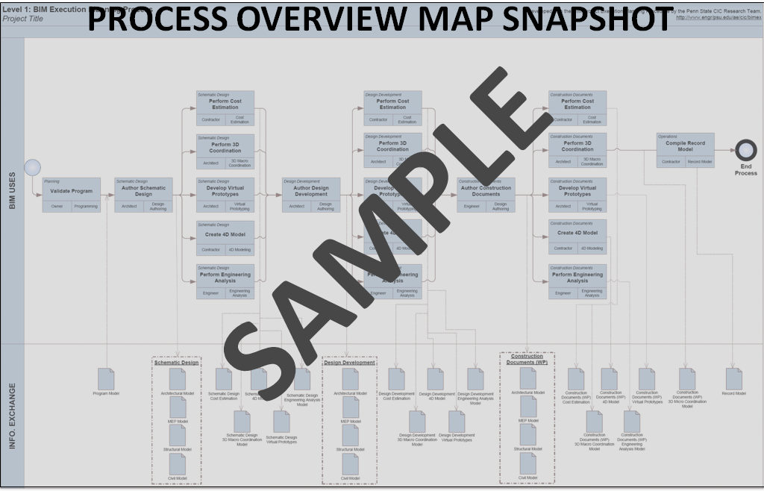

- LEVEL TWO - DETAILED PROCESS MAPS: ATTACHMENT 2
Provide a Level Two (L2) - Detailed Process Map for EACH Project Model Use identified in Section 3.3. Submit each as part of the PxP in Section 14.3, Attachment 2, on 11x17” page size.
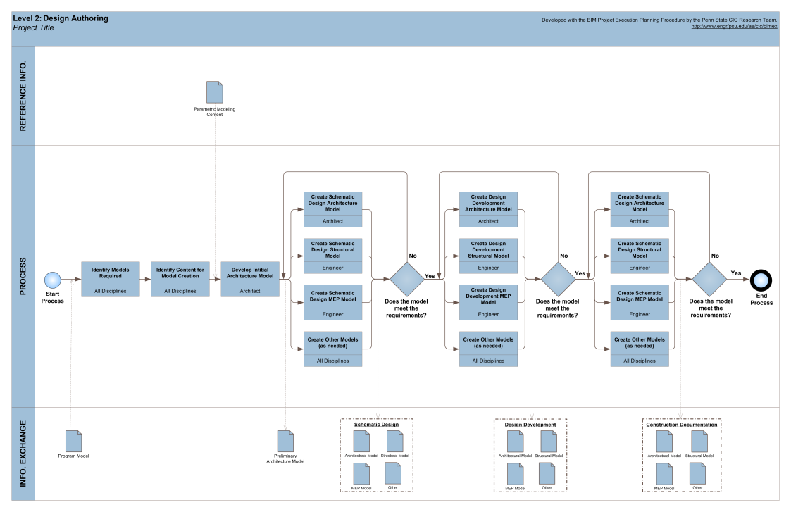

SECTION 6: MINIMUM MODELING AND DATA REQUIREMENTS

MINIMUM MODELING MATRIX (M3): ATTACHMENT 3

Provide an M3 with Column ‘F’ on Tab ‘03. Scope-LOD-Grade’ modified to indicate the Element ID’s included in the Project Scope of Work. Use the M3 Template located at https://cadbimcenter.erdc.dren.mil/ and submit as part of the PxP in Section 14.3, Attachment 3, in PDF and Excel file formats. See M3 Tab ‘01. Instructions’ for additional information.

MODELING ENHANCEMENTS (OPTIONAL)

List enhancements from minimum modeling requirements as specified in Contract. Note: Enhancements MUST exceed minimum requirements of the M3. (i.e. using newer release of A/E/C CAD Standard or IFC Version, modeling all of the plumbing system and not only 1.5” and larger diameter piping, laser scanning for Quality Check install, etc.)
ENHANCEMENT | PURPOSE

SECTION 7: COLLABORATION PROCEDURES
- COLLABORATION STRATEGY
[Concisely describe how the Team will collaborate in development and execution of modeling for the project. Include items such as electronic communication requirements and procedures, document management, software versioning, file transfer and updating, and record storage, etc.]

- COLLABORATION ACTIVITIES
Complete the table to identify and describe collaboration activities conducted by the Team.
ACTIVITY TYPE | REQUIRED PER CONTRACT | PROJECT STAGE | FREQUENCY | PARTICIPANTS | LOCATION
ADVANCED MODELING PxP DEMONSTRATION | [YES] |  | [ONCE] | [CONTRACTOR w/ USACE DISTRICT BIM/CIM MANAGER] | [WEB MEETING OR AGREED LOCATION]
DESIGN COORDINATION | [YES] |  | [INCLUDE ANY VARIANCES DURING DIFFERENT PHASES OF THE PROJECT]
OVER-THE-SHOULDER PROGRESS REVIEWS | [YES] |  |  | [CONTRACTOR w/ AGENT]
CONFIRMATION OF SOFTWARE INTEROPERABILITY |  |  | [BEFORE SOFTWARE CHANGES] | [CONTRACTOR w/ USACE DISTRICT BIM/CIM MANAGER]
[ANY OTHER ADVANCED MODELING ACTIVITY THAT OCCURS WITH MULTIPLE PARTIES, e.g., MODEL UPGRADE STRATEGY]

SECTION 8: QUALITY CONTROL
- STRATEGY FOR QUALITY CONTROL
[Concisely describe the strategy for Quality Control for each of the model files in the project.]

- QUALITY CONTROL CHECKS
The following checks should be performed to assure quality.
CHECKS | REFERENCE DOCUMENT | RESPONSIBLE PARTY | SOFTWARE PROGRAM(S) | SUBMITTAL FREQUENCY
USACE ADVANCED MODELING PxP SUBMITTAL REVIEW CHECKLIST V4.0  (PxP CHX) | USACE Advanced Modeling PxP V4.0, Section 14.5. |  |  | WITH EACH PxP SUBMITTAL
USACE ADVANCED MODELING SUBMITTAL REVIEW CHECKLIST (CHX) | Contract requirements, Paragraph titled Advanced Modeling Submittal Review Checklist. |  |  | ALL
MODEL STANDARDS | Contract Requirements, Paragraph titled Model Standards Checks and Reports. |  |  | ALL
A/E/C CAD STANDARD | Contract Requirements, Paragraph titled CAD Standards Checks and Report |  |  | ALL
A/E/C GRAPHICS STANDARD | Contract Requirements, Paragraph titled Graphics Standards Checks and Report. |  |  | ALL
INTERFERENCE MANAGEMENT  (3D COORDINATION) | USACE Interference Management Standard |  |  | ALL THAT INCLUDE A MODEL
ADDITIONAL PARAMETERS | Contract Requirements, Paragraph titled Additional Parameters
ELECTIVE MODEL USES | Quality Control Plan for Contractor-Elected Model Uses

- INTERFERENCE MANAGEMENT COORDINATION
  - Process. [Describe the process used for executing the required Interference Management Model Use, including how the conflicts in the Coordination Model will be reviewed and resolved.]
  - Disciplines or Trades. The items listed below are typical but not inclusive. Add Disciplines or Trades as required to better visualize and resolve interference management conflicts. An example of an added Discipline/Trade is insulation on piping or mechanical system
  - Color Coding Schemes. Define the Coordination Model color code schemes in the tables below. All model elements in the Coordination Model are to be color-coded by either Discipline/Trade or group. The color schemes do not denote realistic building material, symbology, or print settings.
DISCIPLINE/TRADE COLOR CODE SCHEME
DISCIPLINE/TRADE | COLOR | NAME |  | R | G | B | TRANSPARENCY
[STRUCTURAL] | -- | [MULTIPLE] |  | -- | -- | -- | [0%]
[ARCHITECTURAL] | -- | [UNASSIGNED] |  | [--] | [--] | [--] | [25%]
[MECHANICAL] |  | [ORANGE] |  | [255] | [128] | [0] | [0%]
[PLUMBING] |  | [CYAN] |  | [0] | [255] | [255] | [0%]
[ELECTRICAL] |  | [YELLOW] |  | [255] | [255] | [0] | [0%]
[FIRE PROTECTION] |  | [PINK] |  | [255] | [0] | [127] | [0%]
[SURVEY/MAPPINGS] | -- | [UNASSIGNED] |  | [--] | [--] | [--] | [25%]
[CIVIL] |  | [BROWN] |  | [204] | [102] | [0] | [0%]
[LANDSCAPE] |  | [DARK GREEN] |  | [0] | [153] | [0] | [0%]
[INTERIORS] |  | [LIGHT BLUE] |  | [51] | [153] | [255] | [0%]
[TELECOMMUNICATIONS] |  | [PURPLE] |  | [153] | [51] | [255] | [0%]
GROUP COLOR CODE SCHEME
GROUPS | COLOR | NAME |  | R | G | B | TRANSPARENCY
[STRUCTURAL CONCRETE] |  | [GRAY] |  | [192] | [192] | [192] | [0%]
[STRUCTURAL STEEL] |  | [MAROON] |  | [204] | [0] | [0] | [0%]
[GLAZING] |  | [LIGHT GREEN] |  | [204] | [255] | [204] | [20%]
[SPATIAL RESERVATION] |  | [RED] |  | [255] | [0] | [0] | [80%]

  - Acceptable Clash Types. List any anticipated Acceptable Clash Types and their justification in the table below.
ACCEPTABLE CLASH TYPE | JUSTIFICATION
[Minor penetrations through slab less than 4” and not grouped together] | [Minor holes typically not cut in slabs]
[Domestic water supply of less than 1½” diameter] | [Exceeds requirements of the M3]
[8” diameter Flex Duct in open plenum] | [Can be routed in field]

  - Clash Test Naming Convention. [Provide an example of the Clash Test naming convention that will be used.]

SECTION 9: TECHNOLOGICAL INFRASTRUCTURE NEEDS
List software used, and applicable disciplines identified in Section 2.2 as being included in the project, to execute EACH Project Model Use identified in Section 3.3. Remove Model Uses from tables 9.1 and 9.2 that are not identified as Project Model Uses. Software versions in an approved PxP cannot be changed without concurrence by the USACE BIM/CIM Manager and approval by the Contracting Officer Representative.

- DESIGN PHASE SOFTWARE
DESIGN MODEL USE | DISCIPLINE USER | SOFTWARE | VERSION
DESIGN AUTHORING | [APPLICABLE DISCIPLINE(S)] | [XYZ DESIGN APPLICATION]
PROGRESS REVIEWS
INTERFERENCE MANAGEMENT
(3D COORDINATION)
[STRUCTURAL ANALYSIS]
[LIGHTING ANALYSIS]
[ENERGY ANALYSIS]
[PROGRAM VALIDATION]
[MECHANICAL ANALYSIS]
[OTHER ENG. ANALYSIS]
[SUSTAINABILITY (LEED) EVALUATION]
[CODE VALIDATION]
[PRELIMINARY CONSTRUCTION SCHEDULING (4D)]
[COST ESTIMATION (5D)]
[EXISTING CONDITIONS MODELING]
[FACILITY DATA EXCHANGE (FDE)]
[OTHER ELECTIVE MODEL USE IF APPLICABLE]

- CONSTRUCTION PHASE SOFTWARE

CONSTRUCTION MODEL USE | DISCIPLINE USER | SOFTWARE | VERSION
[SITE UTILIZATION PLANNING] | [APPLICABLE DISCIPLINE(S)] | [XYZ DESIGN APPLICATION]
[CONSTRUCTION SYSTEM DESIGN]
INTERFERENCE MANAGEMENT
(3D COORDINATION)
[DIGITAL FABRICATION]
[3D CONTROL AND PLANNING]
RECORD MODELING
[FIELD / MATERIAL TRACKING]
[DIGITAL LAYOUT]
[CONSTRUCTION SCHEDULING (4D)]
[EXISTING CONDITIONS MODELING]
[FACILITY DATA EXCHANGE (FDE)]
[OTHER ELECTIVE MODEL USE IF APPLICABLE]

- ADVANCED MODELING Standards
Identify the versions of the following standards as required by Contract.

STANDARD | VERSION
PLATFORM CONFIGURATIONS | [Refer to USACE CAD/BIM Technology Center https://cadbimcenter.erdc.dren.mil/ for the latest version of Revit Templates and the A/E/C Work Structure configuration, as applicable to project requirements.]
A/E/C CAD STANDARD | [A/E/C CAD Standard ver. X.0]
A/E/C GRAPHICS STANDARD | [A/E/C Graphics Standard ver. X.0]
IFC | [IFC2x3]
GIS SPATIAL DATA STANDARDS FOR FACILITIES, INFRASTRUCTURE, AND ENVIRONMENT (SDSFIE) | [SDSFIE version]
FACILITY DATA EXCHANGE (IF REQUIRED BY CONTRACT) | [FDE version]

SECTION 10: ADVANCED MODELING ORGANIZATION

- MODEL STRUCTURE
Describe and provide a DIAGRAM how Models are distributed to cover the required project content. For example, by building, floors, floor zones, end use areas, and/or discipline, etc.

- FILE NAMING STANDARDS
As applicable in each category below, provide examples of proposed file names for each discipline identified in Section 2.2 as being included in the project.

  - BIM FILES
Provide file naming convention and samples here or in Section 14.4, Attachment 4; for example,
[PN123456_COF_MECH.dgn (Company Operations Facility, Mechanical content)]
[PN456789_DFAC_ARCH.rvt (Dining Facility, Architectural content)]

  - CIM FILES
Provide file naming convention and samples here or in Section 14.4, Attachment 4; for example,
[PN123456_COF_CIVL.dgn (Company Operations Facility, Civil/Site content)]
[PN246802_WWTP_PLMB.rvt (Waste Water Treatment Plant, Plumbing content)]

  - GIS FILES
Provide file naming convention and samples here or in Section 14.4, Attachment 4; for example,
[PN123456_COF.gdb (Company Operations Facility, file geodatabase, preferred format)]
[PN123456_COF.mdb (Company Operations Facility, personal geodatabase)]

  - CAD FILES
Must comply with the ‘Electronic drawing file naming conventions’ Section of the latest A/E/C CAD Standard. Provide file naming samples here or in Section 14.4, Attachment 4

  - COORDINATION MODEL FILES
Provide file naming convention and samples here or in Section 14.4, Attachment 4; for example,
[PN123456_COF_COORD.dgn (Company Operations Facility, All Disciplines and Trades content)]
[PN456789_DFAC_COORD.nwd (Dining Facility, All Disciplines and Trades content)]

- COORDINATE AND MEASUREMENT SYSTEMS
Provide the Coordinate System (geo-referenced) and Measurement System (Imperial or Metric) required by Contract.

PROJECT COORDINATE AND MEASUREMENT SYSTEMS
COORDINATE SYSTEM | [STATE PLANE] [UTM]
ZONE | [_____]
HORIZONTAL (SITE) UNITS OF MEASURE | [METERS] [US SURVEY FEET] [INTERNATIONAL FEET]
VERTICAL (BUILDING) UNITS OF MEASURE | [METERS] [FEET] [INCHES]
HORIZONTAL DATUM | [NAD 83/2011] [_____]
VERTICAL DATUM | [NAVD 88] [_____]

SECTION 11: PROJECT DELIVERABLES
- CONTRACTUAL PROJECT DELIVERABLES
List the deliverables for the project and the stage and format in which the information will be delivered. Reference the Contract requirements.
ADVANCED MODELING DELIVERABLES | SUBMITTAL  FREQUENCY | FORMAT | NOTES
LIST OF ALL SUBMITTED FILES (EXCEL SPREADSHEET PREFERRED) | [ALL]
ADVANCED MODELING SUBMITTAL REVIEW CHECKLIST (CHX) | [ALL]
ADVANCED MODELING BIM | [ALL]
ADVANCED MODELING CIM | [ALL]
ADVANCED MODELING GIS | [ALL]
ADVANCED MODELING CAD | [ALL]
DRAWING FILES IN PDF FORMAT | [ALL]
3D INTERACTIVE REVIEW MODEL | [ALL]
IFC COORDINATION VIEW | [ALL]
QUALITY CONTROL REPORT – MODEL STANDARDS CHECK | [ALL]
QUALITY CONTROL REPORT – A/E/C CAD STANDARD CHECK. See the CHX, Appendix A | [ALL]
QUALITY CONTROL REPORT – A/E/C GRAPHICS STANDARD CHECK. See the CHX, Appendix B | [ALL]
QUALITY CONTROL REPORT – INTERFERENCE MANAGEMENT REPORT | [ALL] | [PDF]
COORDINATION MODEL | [ALL] | [Autodesk Navisworks (NWD)  or Bentley Navigator (i.DGN)  or Solibri (SMC)]
COORDINATION MODEL FILE EXPORT | [ALL] | [Autodesk Navisworks (HTML)  or Bentley Navigator (XML)  or Solibri (XLS)]
DRAWING INDEX | [ALL]
[OTHER ADVANCED MODELING DELIVERABLES] | [ALL]

- PROJECT DELIVERABLES FOR ELECTIVE MODEL USES
For each Elective Model Use identified in Section 3.3, list the submittal items for the project and the format in which the information will be delivered. Submittals will be provided as ‘For Information Only’.
ELECTIVE MODEL USE | DELIVERABLE | STAGE | FORMAT | NOTES
[ELECTIVE MODEL USE] | [SUBMITTAL ITEM] | [ALL]

SECTION 12: GEOGRAPHIC INFORMATION SYSTEM (GIS)
NOTE: RESERVED FOR FUTURE USE

SECTION 13: GOVERNMENT FURNISHED MATERIAL (GFM)
NOTE: RESERVED FOR FUTURE USE

SECTION 14: ATTACHMENTS
- LEVEL ONE - PROCESS OVERVIEW MAP: ATTACHMENT 1 (From SECTION 5.1)
- LEVEL TWO - DETAILED PROCESS MAPS: ATTACHMENT 2 (From SECTION 5.2)
- MINIMUM MODELING MATRIX (M3): ATTACHMENT 3 (From SECTION 6.1, submitted in Excel and PDF file formats)
- FILE NAMING STANDARD: ATTACHMENT 4 (From SECTION 10.2, AS APPLICABLE)
- ADVANCED MODELING PxP SUBMITTAL REVIEW CHECKLIST (PxP CHX) – V4: ATTACHMENT 5. Every PxP Submittal must include a completed PxP CHX in accordance with the PxP CHX Submitter Instructions. Similar in function to the CHX, it provides a process for checking on the quality of a PxP prior to submittal and as a review tool for USACE reviewer.
- OTHER [AS APPLICABLE]

SECTION 15: TEMPLATE CHANGE LOG
Refer to the “USACE Advanced Modeling PxP Template V3.0 to V4.0 Change Log” document for a record of changes to this template.

Version 3, Section 5.4 BIM Project Execution Plan Content – Version 2.1, BIM Project Execution Plan Template.

